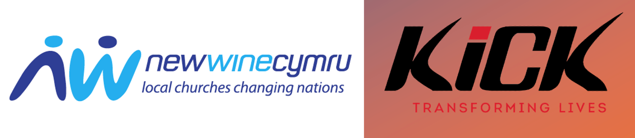

Register Your Interest
If your church would like to explore being part of the KICK Schools initiative:

Name: ________________________________

Church: ________________________________

Location: ________________________________

Questions for Churches Registering Interest

Please complete the following information below for registering your interest. Thank you!

- Do you currently run youth work?

____________________________________________________________

- If yes, how many young people do you regularly see weekly?

_____________________________________________________________

- How many young people attend your Sunday or midweek services?

_____________________________________________________________

- Please provide an age breakdown.

______________________________________________________________

- Do you have an existing relationship with any local schools?

______________________________________________________________

- Are you already engaged with New Wine Cymru’s ministry?

______________________________________________________________
- Are you in agreement with the vision and values of New Wine Cymru?
(See our Values page here for more details.)

_______________________________________________________________

- Do you currently do any outreach into local schools?

________________________________________________________________

- Are you aware of any school’s outreach happening locally that is not run by your church?

________________________________________________________________

- Do you know of any potential people who would like to enquire or would be a link as a KICK coach?

________________________________________________________________

Please save and email your form to:
jezfage@newwinecymru.co.uk

If your church would like to explore being part of the KICK Schools initiative. Please apply by the end of December 2025
We look forward to hearing from you. Many thanks

Julian Richards
Leader of New Wine Cymru


